**Automated Home Irrigation System for Indoor Plants**

With use of Arduino MEGA 2560 controller, I developed indoor automated irrigation system from plants. Due to travel from work certain days of week plants didn’t get water to keep the moist of soil. In order to avoid dryness of soil I had to come up with this automated water supply system as solution so that even in my absence plants will get water as it needed without any human interference.

Components Used/BOM.

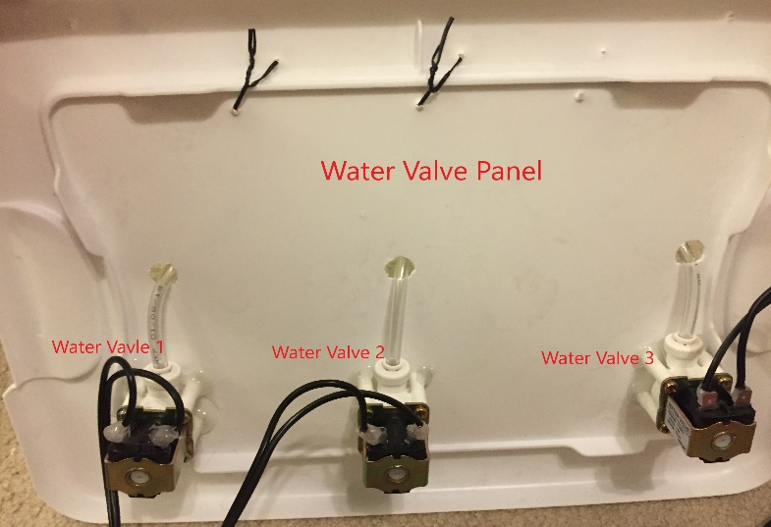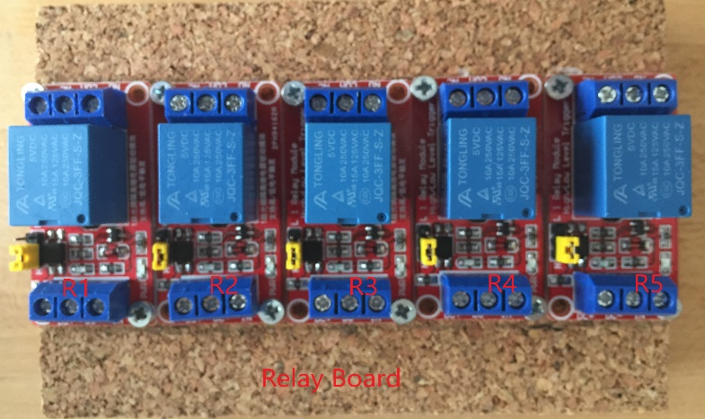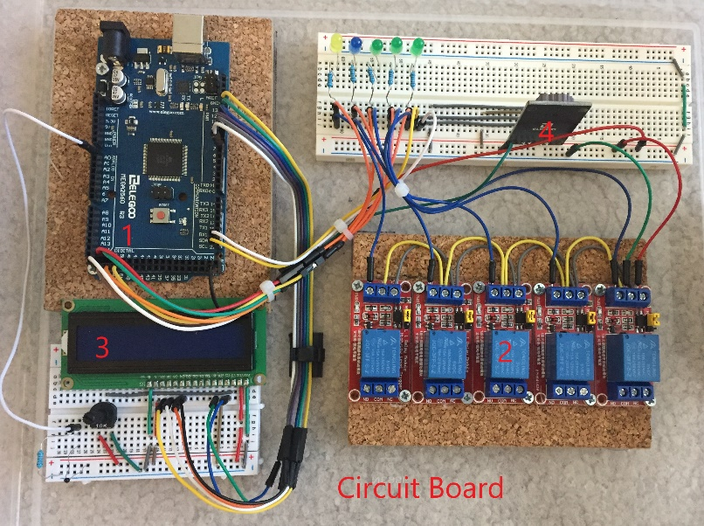**Pictures of Irrigation System During Process of Development**

**Circuit Board**

1 -> Elegoo MEGA 2560 controller

2 -> Relay Board showing 5 different relays used separately for Water pump(R1)-110 VAC, Water Valves (R2, R3, R4)-12 VDC**,** Light Bulb-110 VAC

3 -> LCD display to show Date, Time, Temperature

4 -> DS1307 RTC Module for date and time.

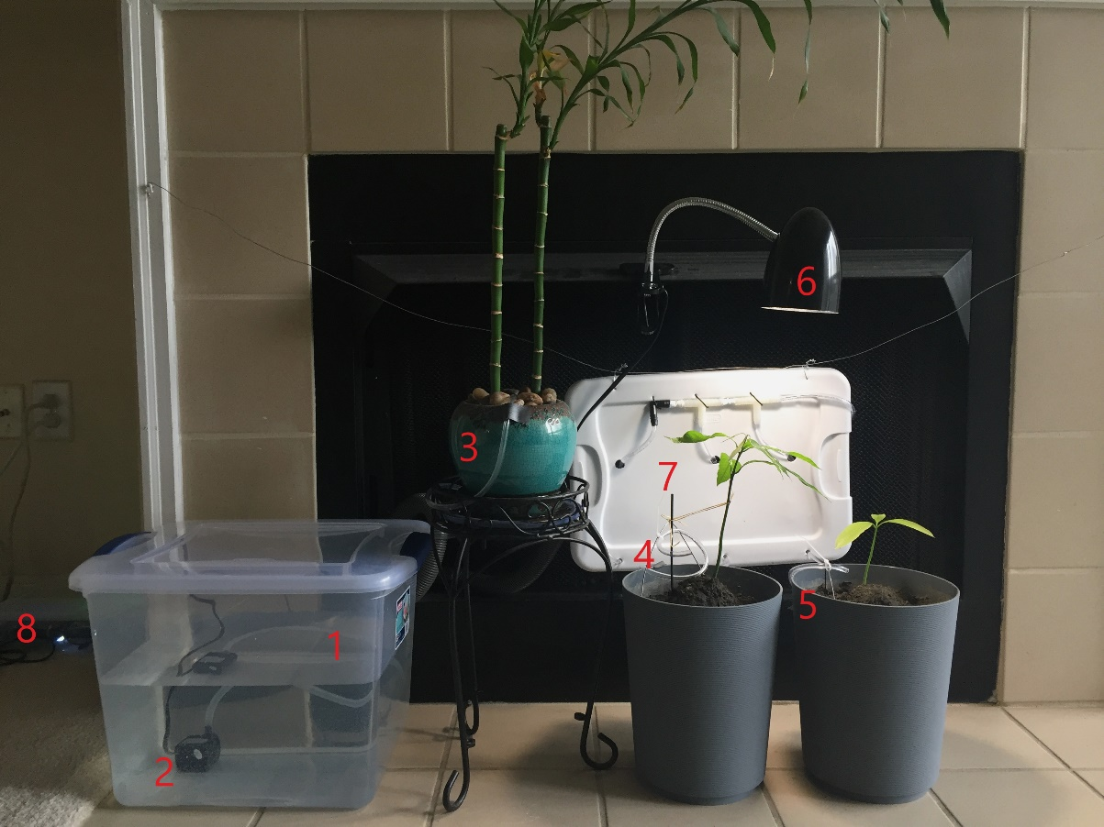**Demo of Indoor Irrigation System in Picture After Development is Completed and System is in Use**

1 -> Water Tank

2 -> Water Pump

3 -> Water Valve No. 3

4 -> Water Valve No. 2

5 -> Water Valve No. 1

6 -> Light bulb for plant

7 -> Water Valves and water pipes panel

8 -> Controller Box Including Relay Board, Arduino Controller, RTC, LCD, Relay Board

User can setup what days of week and how long to run water supply for individual pump. Along with water supply Light bulb can be turn ON for set number of hours for specific days. There’s thermistor sensor to read temperature and DS1307 RTC module to read real time and display on LCD screen. LCD screen also displays real time status of date, time, temperature, water pump and water valves.